**CSA4724-DEEP LEARNING FOR NUTRITION ANALYSIS**

**ZUBAIR AHMED 192124206**

**24.06.2024(DAY 3)**

**7(b)**

**Program:**

import numpy as np

import matplotlib.pyplot as plt

def mean_squared_error(y_true, y_predicted):

    # Calculating the loss or cost

    cost = np.sum((y_true - y_predicted)**2) / len(y_true)

    return cost

# Gradient Descent Function

# Here iterations, learning_rate, stopping_threshold are hyperparameters that can be tuned

def gradient_descent(x, y, iterations=1000, learning_rate=0.0001, stopping_threshold=1e-6):

    # Initializing weight, bias, learning rate and iterations

    current_weight = 0.1

    current_bias = 0.01

    n = float(len(x))

    costs = []

    weights = []

    previous_cost = None

    # Estimation of optimal parameters

    for i in range(iterations):

        # Making predictions

        y_predicted = (current_weight * x) + current_bias

        # Calculating the current cost

        current_cost = mean_squared_error(y, y_predicted)

        # If the change in cost is less than or equal to stopping_threshold we stop the gradient descent

        if previous_cost and abs(previous_cost - current_cost) <= stopping_threshold:

            break

        previous_cost = current_cost

        costs.append(current_cost)

        weights.append(current_weight)

        # Calculating the gradients

        weight_derivative = -(2/n) * sum(x * (y - y_predicted))

        bias_derivative = -(2/n) * sum(y - y_predicted)

        # Updating weights and bias

        current_weight = current_weight - (learning_rate * weight_derivative)

        current_bias = current_bias - (learning_rate * bias_derivative)

        # Printing the parameters for each 100th iteration

        if i % 100 == 0:

            print(f"Iteration {i+1}: Cost {current_cost}, Weight {current_weight}, Bias {current_bias}")

    # Visualizing the weights and cost for all iterations

    plt.figure(figsize=(8, 6))

    plt.plot(weights, costs)

    plt.scatter(weights, costs, marker='o', color='red')

    plt.title("Cost vs Weights")

    plt.ylabel("Cost")

    plt.xlabel("Weight")

    plt.show()

    return current_weight, current_bias

def main():

    # Data

    X = np.array([52.50234527, 63.42680403, 81.53035803, 47.47563963, 89.81320787,

           55.14218841, 52.21179669, 39.29956669, 48.10504169, 52.55001444,

           45.41973014, 54.35163488, 44.1640495 , 58.16847072, 56.72720806,

           48.95588857, 44.68719623, 60.29732685, 45.61864377, 38.81681754])

    Y = np.array([41.70700585, 78.77759598, 82.5623823 , 91.54663223, 77.23092513,

           78.21151827, 79.64197305, 59.17148932, 75.3312423 , 71.30087989,

           55.16567715, 82.47884676, 62.00892325, 75.39287043, 81.43619216,

           60.72360244, 82.89250373, 97.37989686, 48.84715332, 56.87721319])

    # Estimating weight and bias using gradient descent

    estimated_weight, estimated_bias = gradient_descent(X, Y, iterations=2000)

    print(f"Estimated Weight: {estimated_weight}\nEstimated Bias: {estimated_bias}")

    # Making predictions using estimated parameters

    Y_pred = estimated_weight * X + estimated_bias

    # Plotting the regression line

    plt.figure(figsize=(8, 6))

    plt.scatter(X, Y, color='orange')

    plt.plot([min(X), max(X)], [min(Y_pred), max(Y_pred)], color='blue', markerfacecolor='red',

             markersize=10, linestyle='dashed')

    plt.xlabel("X")

    plt.ylabel("Y")

    plt.show()

if __name__ == "__main__":

    main()

**Output:**

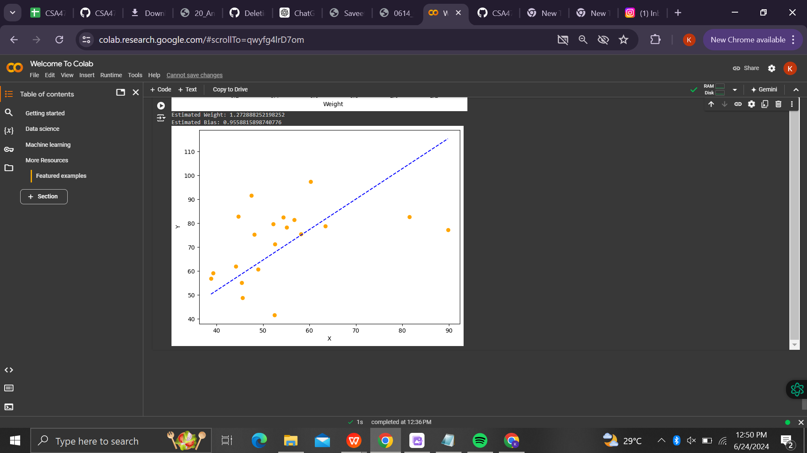

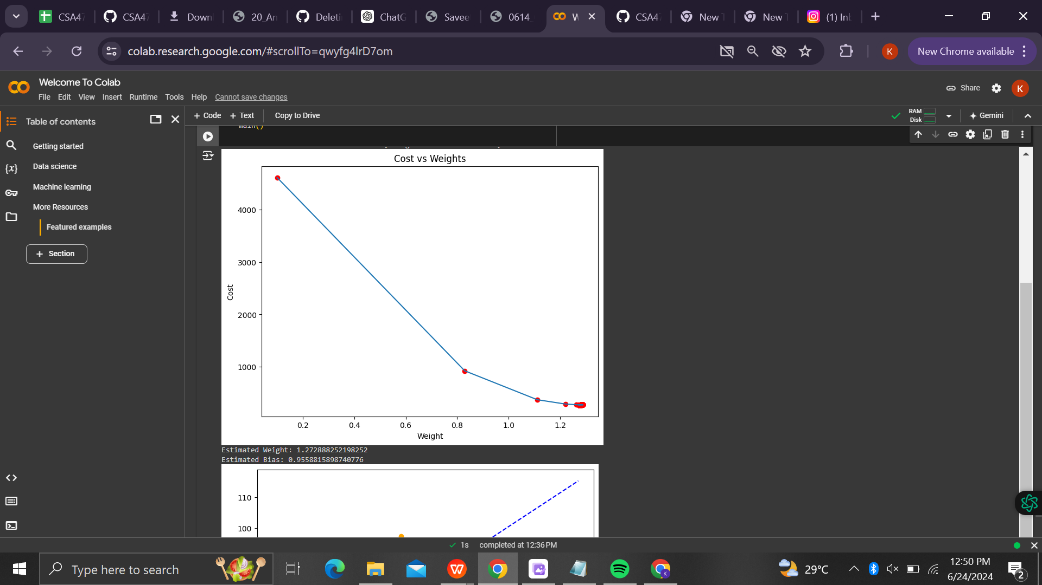

**7(a)**

**Program:**

import numpy as np

import matplotlib.pyplot as plt

def mean_squared_error(y_true, y_predicted):

# Calculating the loss or cost

cost = np.sum((y_true - y_predicted)**2) / len(y_true)

return cost

# Gradient Descent Function

# Here iterations, learning_rate, stopping_threshold are hyperparameters that can be tuned

def gradient_descent(x, y, iterations=1000, learning_rate=0.0001, stopping_threshold=1e-6):

# Initializing weight, bias, learning rate and iterations

current_weight = 0.1

current_bias = 0.01

n = float(len(x))

costs = []

weights = []

previous_cost = None

# Estimation of optimal parameters

for i in range(iterations):

# Making predictions

y_predicted = (current_weight * x) + current_bias

# Calculating the current cost

current_cost = mean_squared_error(y, y_predicted)

# If the change in cost is less than or equal to stopping_threshold we stop the gradient descent

if previous_cost and abs(previous_cost - current_cost) <= stopping_threshold:

break

previous_cost = current_cost

costs.append(current_cost)

weights.append(current_weight)

# Calculating the gradients

weight_derivative = -(2/n) * sum(x * (y - y_predicted))

bias_derivative = -(2/n) * sum(y - y_predicted)

# Updating weights and bias

current_weight = current_weight - (learning_rate * weight_derivative)

current_bias = current_bias - (learning_rate * bias_derivative)

# Printing the parameters for each 100th iteration

if (i + 1) % 100 == 0:

print(f"Iteration {i+1}: Cost {current_cost}, Weight {current_weight}, Bias {current_bias}")

# Visualizing the weights and cost for all iterations

plt.figure(figsize=(8, 6))

plt.plot(weights, costs)

plt.scatter(weights, costs, marker='o', color='red')

plt.title("Cost vs Weights")

plt.ylabel("Cost")

plt.xlabel("Weight")

plt.show()

return current_weight, current_bias

def main():

# Data

X = np.array([32.50234527, 53.42680403, 61.53035803, 47.47563963, 59.81320787,

55.14218841, 52.21179669, 39.29956669, 48.10504169, 52.55001444,

45.41973014, 54.35163488, 44.1640495 , 58.16847072, 56.72720806,

48.95588857, 44.68719623, 60.29732685, 45.61864377, 38.81681754])

Y = np.array([31.70700585, 68.77759598, 62.5623823 , 71.54663223, 87.23092513,

78.21151827, 79.64197305, 59.17148932, 75.3312423 , 71.30087989,

55.16567715, 82.47884676, 62.00892325, 75.39287043, 81.43619216,

60.72360244, 82.89250373, 97.37989686, 48.84715332, 56.87721319])

# Estimating weight and bias using gradient descent

estimated_weight, estimated_bias = gradient_descent(X, Y, iterations=2000)

print(f"Estimated Weight: {estimated_weight}\nEstimated Bias: {estimated_bias}")

# Making predictions using estimated parameters

Y_pred = estimated_weight * X + estimated_bias

# Plotting the regression line

plt.figure(figsize=(8, 6))

plt.scatter(X, Y, color='red')

plt.plot([min(X), max(X)], [min(Y_pred), max(Y_pred)], color='blue', markerfacecolor='red',

markersize=10, linestyle='dashed')

plt.xlabel("X")

plt.ylabel("Y")

plt.show()

if __name__ == "__main__":

main()

**Output:**

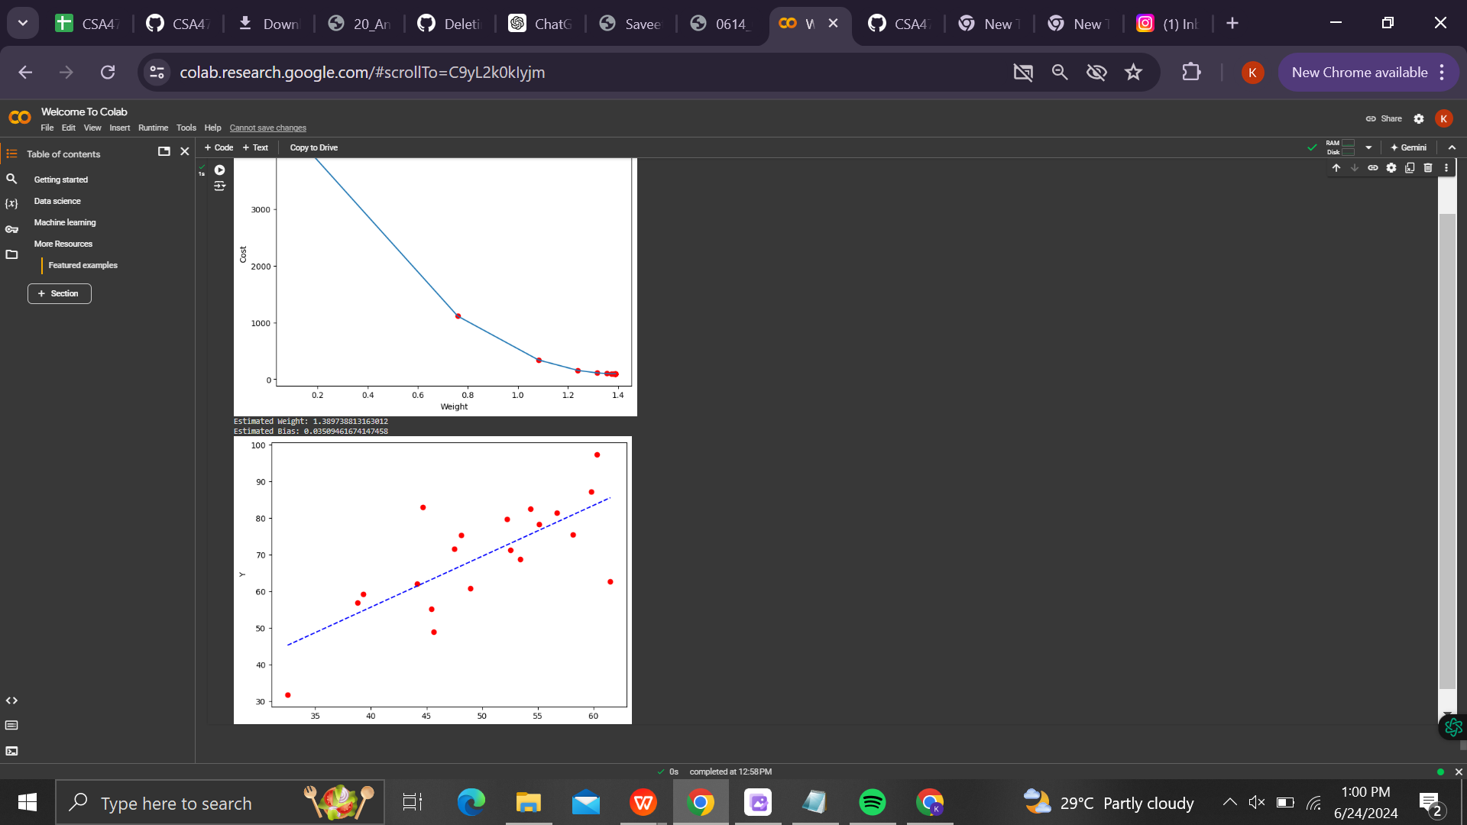

**8(a)**

**Program:**

import tensorflow as tf

from tensorflow.keras import datasets, layers, models

import matplotlib.pyplot as plt

from sklearn.metrics import classification_report, confusion_matrix

import seaborn as sns

import numpy as np

# Load and preprocess the dataset

(X_train, y_train), (X_test, y_test) = datasets.cifar10.load_data()

# Normalize the images to the range [0, 1]

X_train, X_test = X_train / 255.0, X_test / 255.0

# Verify the data

class_names = ['airplane', 'automobile', 'bird', 'cat', 'deer', 'dog', 'frog', 'horse', 'ship', 'truck']

plt.figure(figsize=(10,10))

for i in range(25):

    plt.subplot(5,5,i+1)

    plt.xticks([])

    plt.yticks([])

    plt.grid(False)

    plt.imshow(X_train[i], cmap=plt.cm.binary)

    plt.xlabel(class_names[y_train[i][0]])

plt.show()

# Build the CNN model

model = models.Sequential([

    layers.Conv2D(32, (3, 3), activation='relu', input_shape=(32, 32, 3)),

    layers.MaxPooling2D((2, 2)),

    layers.Conv2D(64, (3, 3), activation='relu'),

    layers.MaxPooling2D((2, 2)),

    layers.Conv2D(64, (3, 3), activation='relu'),

    layers.Flatten(),

    layers.Dense(64, activation='relu'),

    layers.Dense(10)

])

# Compile the model

model.compile(optimizer='adam',

              loss=tf.keras.losses.SparseCategoricalCrossentropy(from_logits=True),

              metrics=['accuracy'])

# Train the model

history = model.fit(X_train, y_train, epochs=10,

                    validation_data=(X_test, y_test))

# Evaluate the model

test_loss, test_acc = model.evaluate(X_test, y_test, verbose=2)

print(f"\nTest accuracy: {test_acc}")

# Make predictions

y_pred = model.predict(X_test)

y_pred_classes = np.argmax(y_pred, axis=1)

# Classification report

print("\nClassification Report:\n")

print(classification_report(y_test, y_pred_classes, target_names=class_names))

# Confusion matrix

conf_matrix = confusion_matrix(y_test, y_pred_classes)

plt.figure(figsize=(10, 8))

sns.heatmap(conf_matrix, annot=True, fmt='d', xticklabels=class_names, yticklabels=class_names, cmap=plt.cm.Blues)

plt.xlabel('Predicted')

plt.ylabel('True')

plt.title('Confusion Matrix')

plt.show()

# Visualize some predictions

plt.figure(figsize=(10, 10))

for i in range(25):

    plt.subplot(5, 5, i + 1)

    plt.xticks([])

    plt.yticks([])

    plt.grid(False)

    plt.imshow(X_test[i], cmap=plt.cm.binary)

    plt.xlabel(f"True: {class_names[y_test[i][0]]}\nPred: {class_names[y_pred_classes[i]]}")

plt.show()

**Output:**

